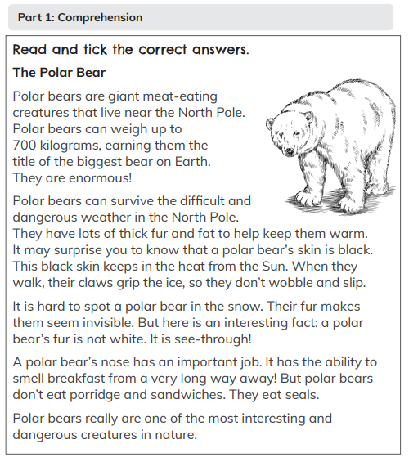Comprehension Questions

1. Where do Polar bears live?
2. How do Polar Bears Survive the cold?
3. What do Polar Bears like to eat?
4. What colour is a Polar Bear’s skin?
5. What is a Polar Bear very good at?

Match the word to its meaning.

award something very big and tall

skeleton a list of jobs each person must do

minibeasts to give someone a prize

giant insects, bug and spiders

rota the bones that keep us standing up

Write each word in the correct place.

|  |  |  |
| --- | --- | --- |
| jump cat tall run fork eat small town hot | | |
| Nouns (a person place or thing) | Verbs (doing words) | Adjectives (describing words) |
|  |  |  |
|  |  |  |
|  |  |  |

Circle the words nearest in meaning to the underlined words.

1. I grabbed the mug before it hit the floor and broke.

dropped caught threw

1. Thomas knocked over the water by mistake.

accidentally on purpose unfortunately

1. There was a sign reminding parents about the book night.

letter text notice

1. We took part in a fun game for PE last week.

activity dance run

1. The dog’s lead was joined to its collar.

pulled attached near